TEACHER: MWALE CHIPO
KENNETH KAUNDA SECONDARY SCHOOL DESIGN AND TECHNOLOGY DEPARTMENT
LESSON PLAN

SUBJECT: DESIGN AND TECHNOLOGY CLASS: DATE:……/……./20…. DURATION:………….

BOYS:…………………… GIRLS ………………………………………. TOTAL OF PUPILS…
TOPIC: BRICKLAYING AND PLASTERING SUBTOPIC: TRADE TOOLS

LEARNING OUTCOMES LSBAT
- Identify classes of bricklaying and plastering hand tools
- Explain the uses identified tools.

RATIONALE
Knowledge: Laying Tools, Cutting Tools, Finishing Tools, Wall Straightening Tools.
Skills: Identification of types of hand tools used in bricklaying Values: Awareness of types of hand tools used in bricklaying TEACHING AIDS.
PART | LESSON CONTENT | METHO DOLOG Y | LEARNER ACTIVITY
introdu ction | - Recap on the previous lesson | Q/A | Provide answers
Development | TRADE TOOLS  CLASSIFICATION OF HAND TOOLS LAYING TOOLS  - Building Trowel Or Brick Trowel  - It is used to pick up mortar and spread it evenly before setting the bricks in their courses.  - It is also used for cutting and trimming of bricks and adjusting brick to line  - Jointing Board:  - To prevent mortar droppings and  - To facilitate the laying of mortal on the narrow webs of the hollow brocks  - Building Square  - Is used for setting out and checking right angle corners for 900  - To check whether or not the angle formed by two walls meeting one another is 900  - Mortal Board Or Spot Board  - Measuring tapes and rules  WALL STRAIGHTENING TOOLS  - Spirit Level  - It is use for checking the alignment of bricks on the face plane when building a corner.  - One tube is used to test vertical work that is plumbing and one tube is used to test horizontal work that is levelling.  - Building Square  - Line And Pine  - Corner Block  CUTTING AND TRIMMING/ MARKING TOOLS  - Bolster Chisel  - Used for the accurate or clean cutting of bricks or blocks and concrete. Is used in conjunction with a brick or club hammer. It should not be used for cutting holes in brick walls.  - Brick Hammer  - Used for rough cutting and trimming of blocks and bricks, plumbing, nailing and general hammer work for rough cutting, very hard bricks which would damage a trowel.  - Cold Chisel  - Used for cutting holes or chase in brick walls.  FINISHING TOOLS  i. Pointing Trowel , Wooden Float, Plastering trowel  EQUIPMENT  a. Wheel-barrows, Metal Peg, Wire Brush, Rough-Casting Machine Metal Peg
Applicat ion | CLASS EXERCISE  - Identify four classes of bricklaying and plastering hand tools  - Explain the uses of the following tools  - Spirit level , Building square , Building trowel | Questio ns  And Answers | Provide answers
Conclu sion | - Recap on the main steps and points | V/E

LESSON EVALUATION

TEACHER: MWALE CHIPO

KENNETH KAUNDA SECONDARY SCHOOL DESIGN AND TECHNOLOGY DEPARTMENT

LESSON PLAN

SUBJECT: DESIGN AND TECHNOLOGY CLASS: DATE:……/……./20…. DURATION:………….

BOYS:…………………… GIRLS ………………………………………. TOTAL OF PUPILS…
TOPIC: BUILDING MATERIALS SUBTOPIC: BRICKS

LEARNING OUTCOMES LSBAT
  - Define Brick
  - State Raw Materials of bricks
  - Explain characterises and properties of clay
  - State and explain Classification of bricks

RATIONALE
Knowledge. Clay and its properties, classification of bricks
Skills: Identification of different types of bricks
Values: Awareness of application of bricks

TEACHING AIDS
PART | LESSON CONTENT | METHOD OLOGY | LEARNER ACTIVITY
Intro ductio n | recap of the previous lesson | Questions and answers | Provide answers
Development | BRICKS  - The term brick refers to small units of building material, often made from tired clay and secured with mortar, a biding agent composing of cement, sand and water.  RAW MATERIALS  - Clay is one of the most abundant natural mineral materials on earth.  - Bricks are made from either clay or a mixture of sand and cement  PROPERTIES AND CHARACTERISTICS OF CLAY  - Must have plasticity, which permits them to be shaped or molded when mixed with water;  - They must have sufficient wet and air-dried strength to maintain their shape after forming.  - The clay particles must fuse together  Classification of bricks  - Machine pressed  Clay bricks are manufactured by preparing clay in a roller pan and lightly pressing the clay into moulds by machinery.  - Wire -cut bricks.  A column of clay is forced through a steel die measuring approximately 215mm by 102-105mm.  - Engineering bricks  These bricks have high strength and low water absorption and are classified as class A and class B.  - Facing bricks  These bricks are manufactured to give on attractive and consistent appearance.  - Common bricks-  These types of bricks are suitable for general construction work where their appearance is not important.
Appli cation | Class exercise  - Define Brick  - State Raw Materials of bricks  - Explain characterises and properties of clay material  - State and explain Classification of bricks | Question and answers | Provide answers
Concl usion | Recap on the main points

TEACHER: MWALE CHIPO

KENNETH KAUNDA SECONDARY SCHOOL DESIGN AND TECHNOLOGY DEPARTMENT
LESSON PLAN

SUBJECT: DESIGN AND TECHNOLOGY CLASS: DATE:……/……./20…. DURATION:………….

BOYS:…………………… GIRLS ………………………………………. TOTAL OF PUPILS…
TOPIC: BUILDING MATERIALS SUBTOPIC: THE MANUFACTURING PROCESS OF CLAY BRICKS

LEARNING OUTCOMES LSBAT
- Explain Manufacturing Process Of Clay Bricks
- State Methods of drying clay bricks
- Identify machines used in manufacturing bricks
- State Method of making Clay Bricks

RATIONALE
Knowledge. Manufacturing Process of Clay Bricks, Methods of drying clay bricks
Skills: Identification of methods of drying clay bricks
Values: Awareness of Methods of drying clay bricks and Manufacturing Process of Clay Bricks

TEACHING AIDS
PART | LESSON CONTENT | METHOD OLOGY | LEARNER ACTIVITY
Introd uction | Recap of the previous lesson | Questions and answers | Provide answers
Development | KNEADING THE CLAY  THE MANUFACTURING PROCESS OF CLAY BRICKS  The process of manufacturing of bricks from clay involves  - PREPARATION OF CLAY,  - Unsoiling of clay. The top layer of soil may contain impurities, so the clay in top layer of soil about 200mm depth is thrown away.  - Cleaning, Clay is cleaned of stones; vegetable matter etc. if large quantity of particulate matter is present, and then the clay is washed and screened.  - The lumps of clay are converted into powder with earth crushing rollers. Grinding, sizing and combination of materials  - MOULDING  - Prepared clay is mold into brick shape (generally rectangular).  This process can be done in two ways according to scale of project  - Hand molding ( for small scale)  - Machine molding ( for large scale)  - DRYING.  - Hacking is the process of loading a kiln car or kiln with bricks  - They are dried to remove excess moisture that might otherwise cause cracking during the ensuring firing process  Types of dryers  - Tunnel dryers use cars to move the brick through humidity controlled zones that prevent cracking.  - Natural drying  - BURNING OF BRICKS.  - In the process of burning, the dried bricks are burned either in clamps (small scale) or kilns (large scale) up to certain degree temperature  Brick are fired between 10 and 40 hours
Applic ation | CLASS EXERCISE  a. Identify and explain the four stages in the process of manufacturing of bricks | Question and answers | Provide answers
Concl usion | Recap on the main points | Verbal exposition

TEACHER: MWALE CHIPO

KENNETH KAUNDA SECONDARY SCHOOL DESIGN AND TECHNOLOGY DEPARTMENT
LESSON PLAN

SUBJECT: DESIGN AND TECHNOLOGY CLASS: DATE:……/……./20…. DURATION:………….

BOYS:…………………… GIRLS ………………………………………. TOTAL OF PUPILS…
TOPIC: BUILDING MATERIALS SUBTOPIC: THE MANUFACTURING PROCESS OF CLAY BRICKS

LEARNING OUTCOMES LSBAT
- State Methods of drying clay bricks
- Identify machines used in manufacturing bricks
- State Method of making Clay Bricks

RATIONALE
Knowledge. Manufacturing Process of Clay Bricks, Methods of drying clay bricks
Skills: Identification of methods of drying clay bricks
Values: Awareness of Methods of drying clay bricks and Manufacturing Process of Clay Bricks

TEACHING AIDS
PART | LESSON CONTENT | METHOD OLOGY | LEARNER ACTIVITY
Introd uction | Recap of the previous lesson | Questions and answers | Provide answers
Development | THE MANUFACTURING PROCESS OF CLAY BRICKS SETTING AND PACKAGING  - After the bricks are fired and cooled, it is unloaded from the kiln car through DE hacking process  - De-hacking is the process of unloading a kiln or kiln car after the brick have cooled  METHOD OF MAKING CLAY BRICKS  Clay bricks can be made using the following processes or procedures  - Soft process  - dry process  - moulding process  Methods of drying clay bricks  - Artificial drying (hot floor, chamber tunnel)  - Natural drying (sun dried)  MACHINES USED IN MANUFACTURING BRICKS  - Chamfering machines  Can produces as many as 20,000 units per hour  - Vacuum extrusion clay brick machine  THE MANUFACTURING PROCESS OF CLAY BRICKS  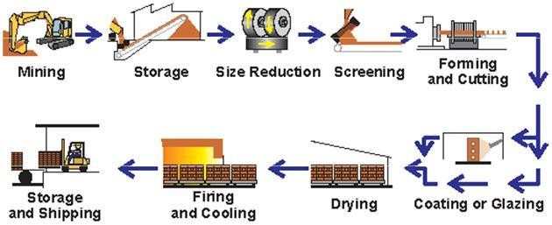
Applic ation | CLASS EXERCISE  - Explain the following terms  - Hacking  - De-hacking  - State three Methods of making Clay Bricks  - State two machines used in manufacturing of bricks | Question and answers | Provide answers
Concl usion | Recap on the main points | Verbal exposition

TEACHER: MWALE CHIPO

DESIGN AND TECHNOLOGY DEPARTMENT
LESSON PLAN

SUBJECT: DESIGN AND TECHNOLOGY CLASS: DATE:……/……./20…. DURATION:………….

BOYS:…………………… GIRLS ………………………………………. TOTAL OF PUPILS…
TOPIC: BUILDING MATERIALS SUBTOPIC: BLOCKING MAKING

LEARNING OUTCOMES LSBAT
- Define Block
- State two types of clay blocks
- Explain three basic forms of concrete blocks

RATIONALE
Knowledge. The standard six-cavity, three-cavity block, Solid blocks, Cellular blocks, Hollow blocks
Skills: Identification of clay blocks and concrete blocks
Values: Awareness of mix materials for block making, curing and storage or stacking of blocks

TEACHING AIDS
PART | LESSON CONTENT | METHOD OLOGY | LEARNER ACTIVITY
Intro ductio n | Recap of the previous lesson | Questions and answers | Provide answers
Development | BLOCKING MAKING  - A block is a walling unit exceeding the dimensions specified for bricks and having a height not exceeding either its length or six times its thickness to avoid confusion with slabs or panels.  CLAY BLOCKS.  - These are hollow blocks made by an extrusion process and then fired in the same way as clay bricks.  TWO TYPES OF CLAY BLOCKS.  - The standard six-cavity-  Block that is mainly used for the inner skin of the cavity walls and  - The three-cavity block  This is a partitioning block primarily used for partitioning work.  CONCRETE BLOCKS  - These are made from a mixture of hard, durable and clean sand.  - These blocks can be used after about 14 days under normal to avoid blocks shrinkages  THREE BASIC FORMS OF CONCRETE BLOCKS  - Solid blocks  - The blocks have no formed voids.  - Cellular blocks  - These blocks have one or more voids but do not pass right through the block.  - In short they are stopped voids.  - Hollow blocks  - These have one or more voids which pass through the block from one opposite surface to another.  - Blocks having one or more holes that is open at both sides  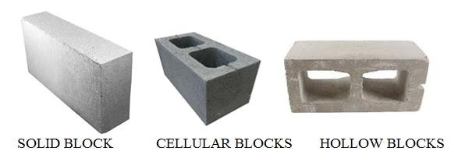
Appli cation | CLASS EXERCISE  - State two types of clay blocks  - Explain three basic forms of concrete blocks | Question and answers | Provide answers
Concl usion | Recap on the main points | Verbal exposition

TEACHER: MWALE CHIPO

DESIGN AND TECHNOLOGY DEPARTMENT LESSON PLAN

SUBJECT: DESIGN AND TECHNOLOGY CLASS: DATE:……/……./20…. DURATION:………….

BOYS:…………………… GIRLS ………………………………………. TOTAL OF PUPILS…
TOPIC: BUILDING MATERIAL SUBTOPIC: BINDERS / MATRIX AND AGGREGATES

LEARNING OUTCOMES LSBAT
  - Define aggregates
  - Explain types of aggregates used in building
  - State two types of binders /matrix material used in building

RATIONALE
Knowledge: Aggregates, binder/matrix, building units (clay bricks, concrete blocks) Skills: Identification types of building materials, classification of building materials Values: Awareness of types building materials

TEACHING AIDS
Course aggregates, cement, lime, fine aggregates
PART | LESSON CONTENT | METHO DOLOG Y | LEARNER ACTIVITY
Introdu ction | - Recap on the previous lesson | Q/A | Provide answers
Development | BUILDING MATERIAL AGGREGATE  - The term aggregate refer to the inert materials that make the bulk, durability and resistance abrasion.  TYPES OF AGGREGATES  They are classified as fine and course aggregates  - FINE AGGREGATES  - Pit sand / building sand  - River sand/ quary dust  - COURSE AGGREGATES  - Gravel/ crushed stones  - Chippings  QUALITY OF AGGREGATES  - They should be free from salt content and vegetable materials and stones that can easily be disintegrated (broken down)  BINDERS / MATRIX  - LIME  - Pure lime (calcium Oxide) is obtained by burning limestone in the kiln.  - Quick lime is dangerous as it generates a lot of heart and many expand when water is added.  TYPE OF LIMES  - Eminently hydraulic  - Hardens so quickly high strength  - It is made from the limestone which contains impurities such as alumina, silica and iron oxide  - Semi Hydraulic Lime  - This lime contains small amount impurities, thus will slowly harden.  - Non Hydraulic Lime  - This is lime are known as fat or rich lime and will not harden under wet conditions setting/ harden take place by taking in air  - CEMENT  - Cement is made from the clay and limestone  - Cement has the ability to bind particles or gravel or sand together
Applicat ion | CLASS EXERCISE  - Define aggregates  - State two types aggregates  - State two types of binders/matrix use in building | Questions And Answers | Provide answers
Conclus ion | - Recap on the main steps and points | V/E

TEACHER: MWALE CHIPO

DESIGN AND TECHNOLOGY DEPARTMENT LESSON PLAN

SUBJECT: DESIGN AND TECHNOLOGY CLASS: DATE:……/……./20…. DURATION:………….

BOYS:…………………… GIRLS ………………………………………. TOTAL OF PUPILS…
TOPIC: BUILDING MATERIALS SUBTOPIC: MORTAR

LEARNING OUTCOMES LSBAT
  - Define Mortar
  - Explain types of mortar.

RATIONALE
Knowledge: Mortar, types of mortar and mixing procedures
Skills: Mixing of mortars and concretes.
Values: Awareness of safety precaution when working with mortars and concretes

TEACHING AIDS
PART | LESSON CONTENT | METHO DOLOG Y | LEARNER ACTIVITY
introdu ction | - Recap on the previous lesson | Q/A | Provide answers
Development | MORTAR  - Mortar is the Material used in bedding bricks, blocks or stones when constructing walls  REQUIREMENT FOR MORTARS  - Workability  - Mortar should not be harsh  - Must be easy to work with  - Cement used for mortar should not contain lumps MIXING  - Can be mixed by hand or machine  - Water should only be sufficient enough to enhance workability  - The use of batch permits quality control  RATIO  - The mixture is usually one part cement and four parts sand (1:4).  - Where lime has been added, the ratio is usually 1:1:6  ➢
Application | CLASS EXERCISE  - Define Mortar  - State types of mortar  - State the ratio mixing for the following  - Cement sand Mortar and Lime sand mortar | Questions And Answers | Provide answers
Conclus ion | - Recap on the main steps and points | V/E
LESSON EVALUATION

TEACHER: MWALE CHIPO

DESIGN AND TECHNOLOGY DEPARTMENT
LESSON PLAN

SUBJECT: DESIGN AND TECHNOLOGY CLASS: DATE:……/……./20…. DURATION:………….

BOYS:…………………… GIRLS ………………………………………. TOTAL OF PUPILS… TOPIC: BONDS SUBTOPIC: BONDS
LEARNING OUTCOMES LSBAT
  - Define Brick and Bond
  - Explain purpose of bonding
  - Identify and explain types of bonds used in construction

RATIONALE
Knowledge: Parts of a brick, 1. Stretcher Bond, English Bond, Flemish Bond
Skills: Identification of bonds. Application of bonds
Values: Awareness of bonds

TEACHING AIDS
PART | LESSON CONTENT | METHO DOLOG Y | LEARNER ACTIVITY
introdu ction | - Recap on the previous lesson | Q/A | Provide answers
BRICK
Brick is the walling unit for construction of wall PARS OF A BRICK
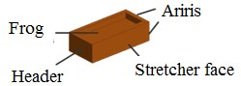
BONDS
- Bond is the pattern in which bricks are laid
PURPOSE OF BONDING
- To strengthen a wall
- To ensure that the any loads are distrusted, bonding the bricks distributes the loads evenly
- To make sure that it is able to resist sideways
THREE TYPES OF BONDS USED IN CONSTRUCTION
- Stretcher Bond
- English Bond
- Flemish Bond STRETCHER BOND
- All bricks on the face of the wall are laid on the stretcher side of the brick.
- Half bricks are used on corners
- Usually a course starting with a half brick ends with a half brick
- Three quarter bricks are used on cross junction to help maintain bon
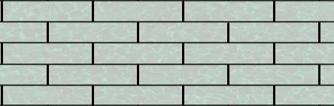
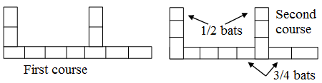
Applicatio n | CLASS EXERCISE  - Define Brick and Bond  - Explain purpose of bonding  - Identify and explain types of bonds used in construction | Questions And Answers | Provide answers
Conclus ion | - Recap on the main steps and points | V/E

TEACHER: MWALE CHIPO

DESIGN AND TECHNOLOGY DEPARTMENT

LESSON PLAN

SUBJECT: DESIGN AND TECHNOLOGY CLASS: DATE:……/……./20…. DURATION:………….

BOYS:…………………… GIRLS ………………………………………. TOTAL OF PUPILS… TOPIC: BONDS SUBTOPIC: BONDS
LEARNING OUTCOMES LSBAT
  - Explain Flemish Bond and English Bond used in construction

RATIONALE
Knowledge:
Skills:
Values:
TEACHING AIDS
PART | LESSON CONTENT | METHO DOLOG Y | LEARNER ACTIVITY
introdu ction | - Recap on the previous lesson | Q/A | Provide answers
Development | BONDS  ENGLISH BOND  - Consists of alternate courses of headers and stretchers  - Uses a quarter brick called Queen Closer, to break vertical joints  - Queen Closer is place after the first header and before the last header in a course Considered the strongest brick bond  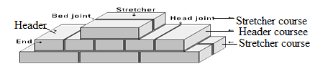  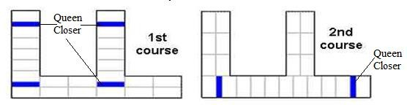  FLEMISH BOND  - Consists alternating stretchers and headers, or one stretcher between headers  - Headers are placed centrally over the stretcher in the course below or/a  - A Queen Closer is placed next to the quoin header at either a stopping end or at a corner to prevent continuous vertical joint.  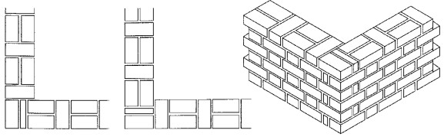
Applicati on | CLASS EXERCISE  - Define Brick and Bond  - Explain purpose of bonding  - Identify and explain types of bonds used in construction | Questions And Answers | Provide answers
Conclu sion | - Recap on the main steps and points | V/E

TEACHER: MWALE CHIPO

DESIGN AND TECHNOLOGY DEPARTMENT LESSON PLAN

SUBJECT: DESIGN AND TECHNOLOGY CLASS: DATE:……/……./20…. DURATION:………….
BOYS:…………………… GIRLS ………………………………………. TOTAL OF PUPILS… TOPIC: BUILDING MATERIAL SUBTOPIC: TERMS USED IN BONDING LEARNING OUTCOMES LSBAT

Explain terms used in bonding
RATIONALE
Knowledge: Terms used in Bonding,
Skills: Identification terms used in construction Values: Awareness of types building materials TEACHING AIDS
PART | LESSON CONTENT | METHO DOLOG Y | LEARNE R ACTIVIT Y
Introd uction | - Recap on the previous lesson | Q/A | Provide answers
Development | TERMS USED IN BONDING  Toothing Or Toothed End  - A way of providing for the future extension of a wall by leaving alternate courses recessed,  Racking Back  - This is another way of providing for the future extension of a wall. The wall is made a lap shorter with each course built.  Return Wall  - A junction between two, usually external walls  Stretcher  - A brick laid with a long side showing on the face of the wall  Header  - A brick laid with an end showing on the face of the wall.  Rules Of Bonding  - A quarter bond is obtained by introducing a queen closer next to a corner or end header  - No cut brick less than a closer must appear on the face of the wall  - When the wall changes direction, the bond must also change the same course
Application | CLASS EXERCISE  - Draw for the following  - Toothing Or Toothed End  - Racking Back wall  - Return Wall  - Why dry bonding is important? | Questions And Answers | Provide answers
Concl usion | - Recap on the main steps and points | V/E

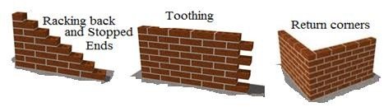

LESSON EVALUATION

